**MINISTRY OF EDUCATION AND TRAINING**

**FPT UNIVERSITY**

Capstone Project Document

Website of Law Firm Management System

Report #6 – Software User’s Manuals

|  |  |
| --- | --- |
| Group 14 | |
| Group Members | Lê Duy Hoàng – Team Leader – SE60744  Đặng Nguyễn Khiêm – Team Member – SE60595  Trần Anh Tuấn – Team Member – SE60631  Phạm Văn Duy – Team Member – SE60634 |
| Supervisor | Nguyễn Văn Sang |
| Capstone Project code | LFMS |

- Ha Noi, 09/2014 –

Contents

6.1. Installation Guide 3

6.1.1. Introduction 3

6.1.2. Environment 3

6.1.3. Application Installation 3

6.2. User’s Guide 11

6.2.1. How to create a Calendar Event 11

6.2.2. How to view calendar event of other lawyer 12

6.2.3. How to create an Operation Event 13

6.2.4. How to upload photos to Documents Related 14

6.2.5. How to create a case 14

6.2.6. How to create a customer 15

6.2.7. How to create a Staff 17

6.2.8. How to create a service 18

6.2.9. How to create an office 19

6.2.10. How to view statistic 20

## Installation Guide

### Introduction

This document contains guide-lines step by step to use LFMS application, and set up its own database.

### Environment

Following are the software required to start the LFMS System:

- Operating System: Windows 7, Windows 8.

- Application server: LFMS application system requires an application server IIS version 7 running on Windows 7

- Browsers: Firefox 20 or higher.

- .NET 4.0 Framework

- Database: SQL Server 2008

- Tool: Microsoft visual studio 2010

### Application Installation

#### Database creation

Please follow these steps to create a new database for system:

* **Step 1**: Preparing database

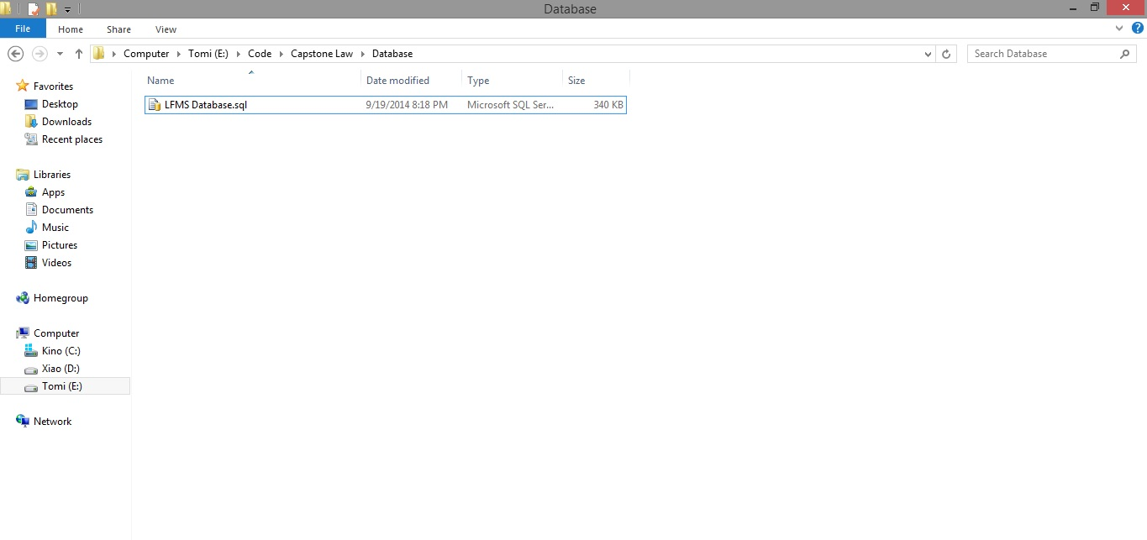

They include a .sql file. The .sql file is database SQL scrip file.

**Step 2**: Import database to SQL Server

Open Script file database using SQL Server

Copy user’s directory that has install SQL Server and replace this location in script file.

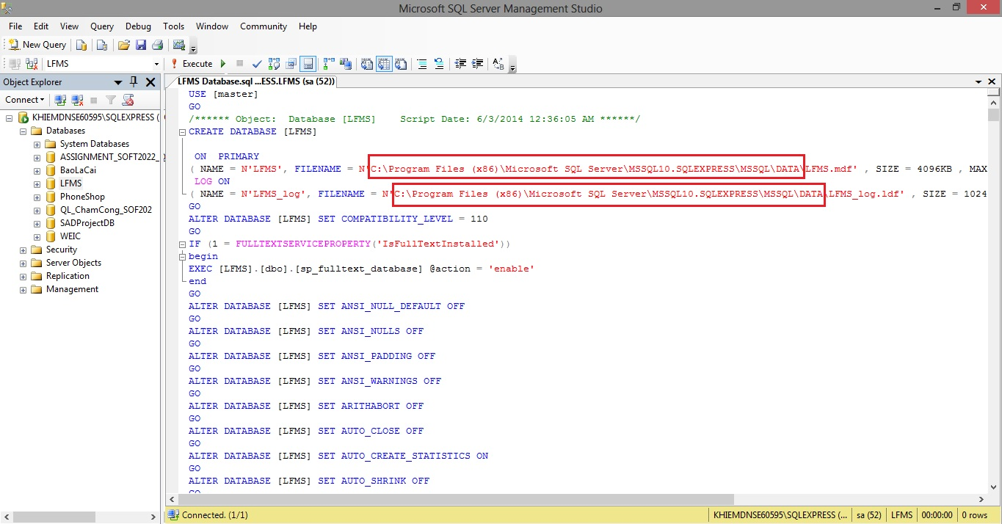

Excute script file to add new database into SQL Server

#### Setup Internet Information Services(IIS)

**Step 1**: Go Start 🡪 Control panel 🡪 Click on Programs and Features 🡪 Click on Turn Windows features on or off.

**Step 2**: Select this features in the picture below to install IIS Service.

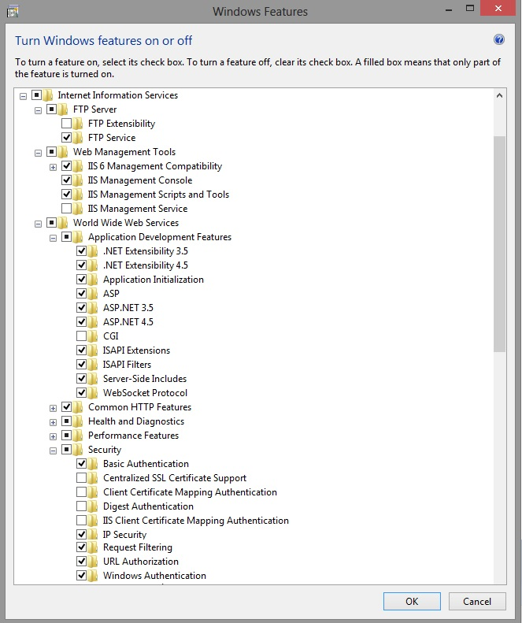

**Step 3**: Go Start 🡪 type Run 🡪 input inetmgr

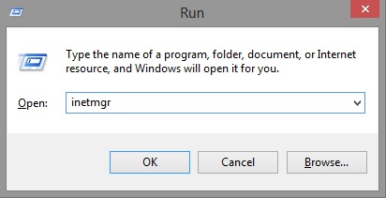

**Step 4:** Go Application Pools 🡪 Right click to select Add Application Pool 🡪 Setup this like the picture below.

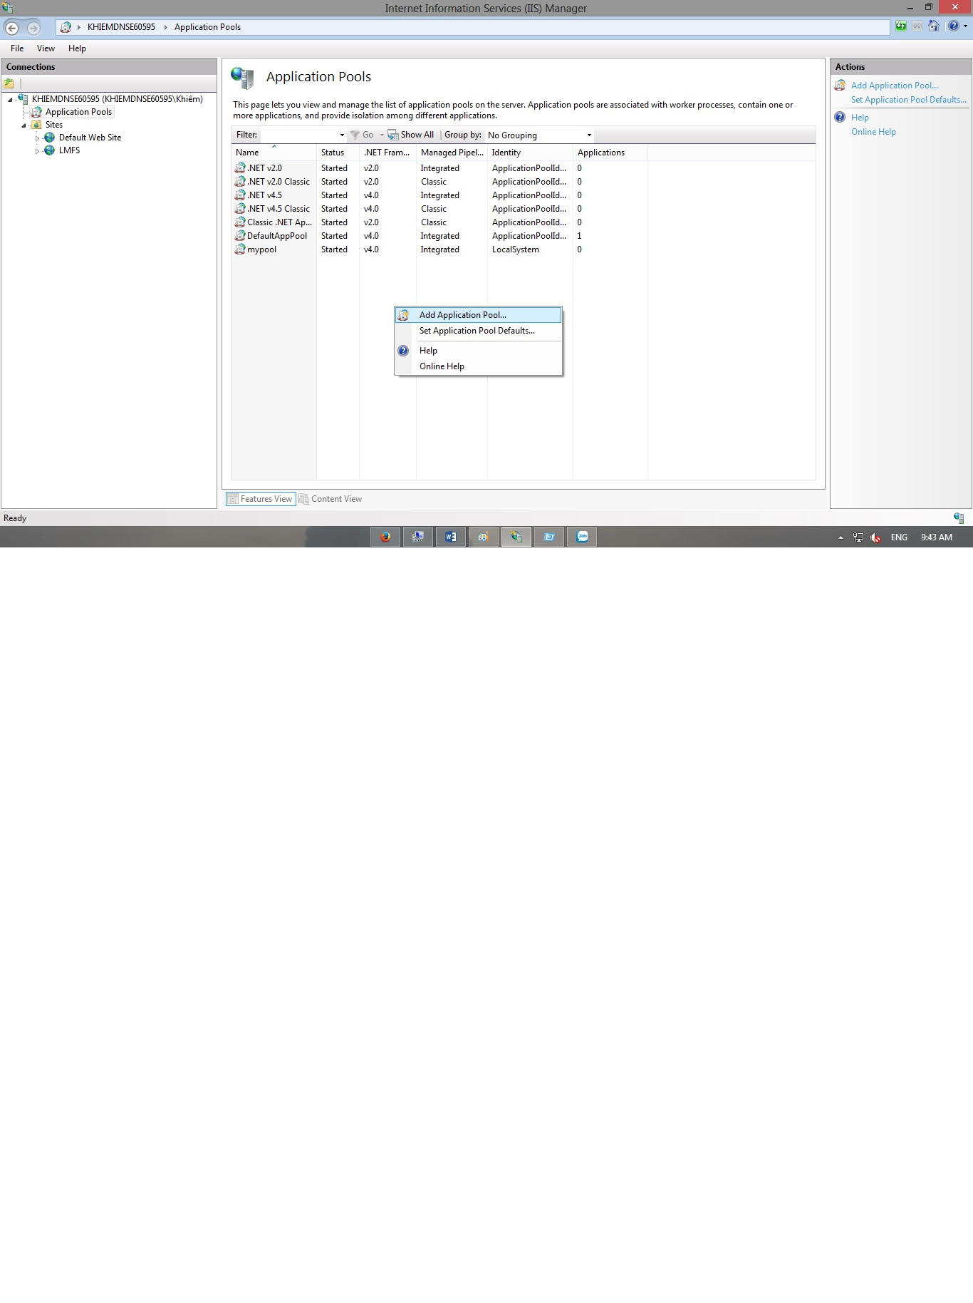

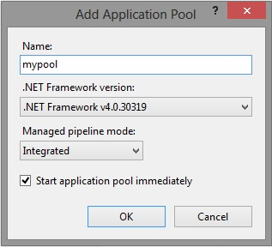

**Step 5:** Open Microsoft SQL Server Management Studio 🡪 Go Security 🡪 Right click to select New Login 🡪 Setup this like the picture below

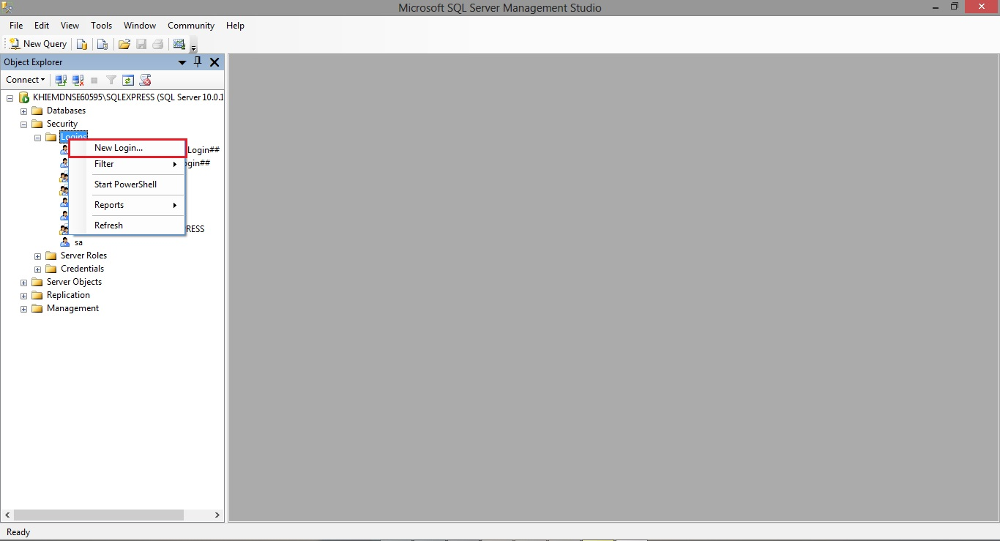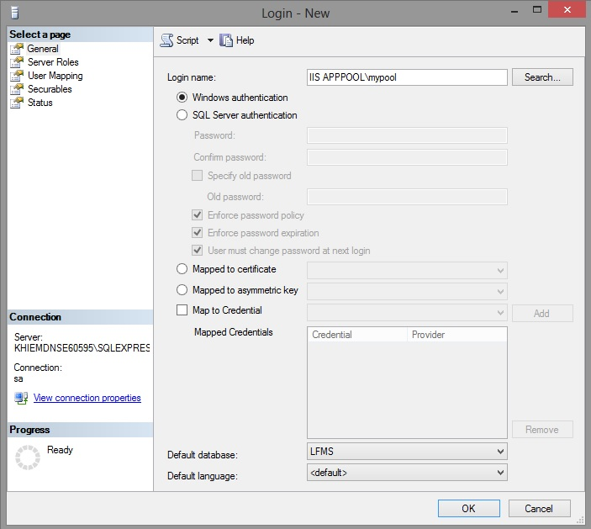

**Step 6:** Go to login user has been created 🡪 Right click then select Properties 🡪 Click on User Mapping 🡪 Setup this like the picture below

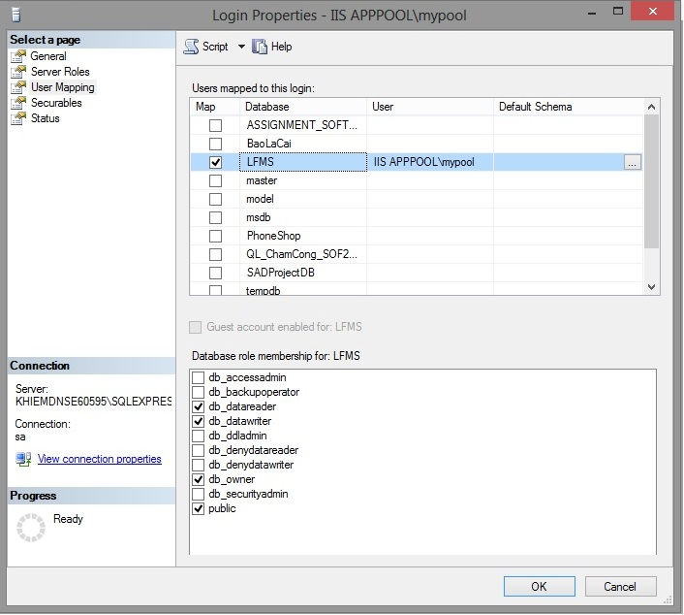

#### Setup and Deloy website into IIS

**Step 1:** Go Sites 🡪 Right click to select Add Website 🡪 Setup this like the picture below.

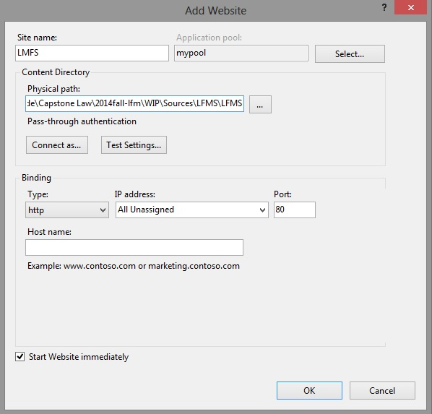

**Step 2:** Goto website user has been created 🡪 Double click on Directory Browsing 🡪 Make this select Enable like the picture below.

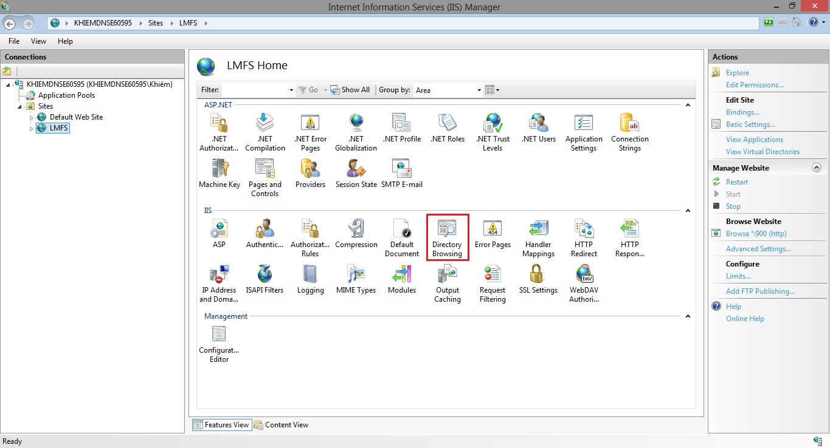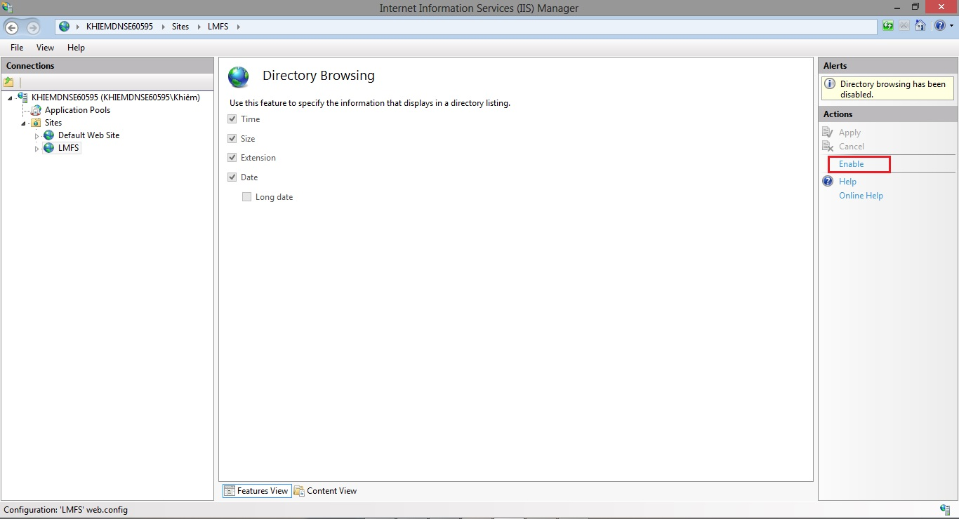

**Step 3:** Goto website user has been created 🡪 Right click to select Manage website 🡪 Choose Browse like the picture below.

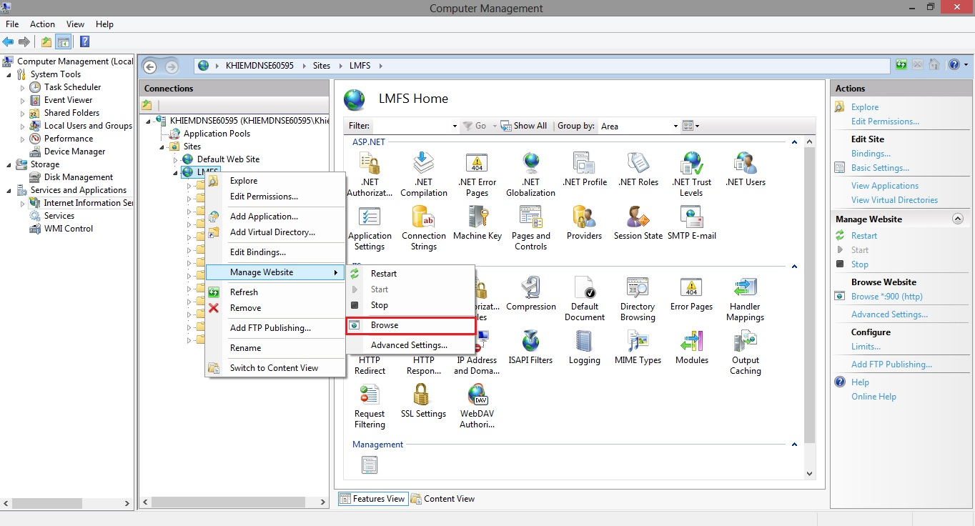

## User’s Guide

### How to create a Calendar Event

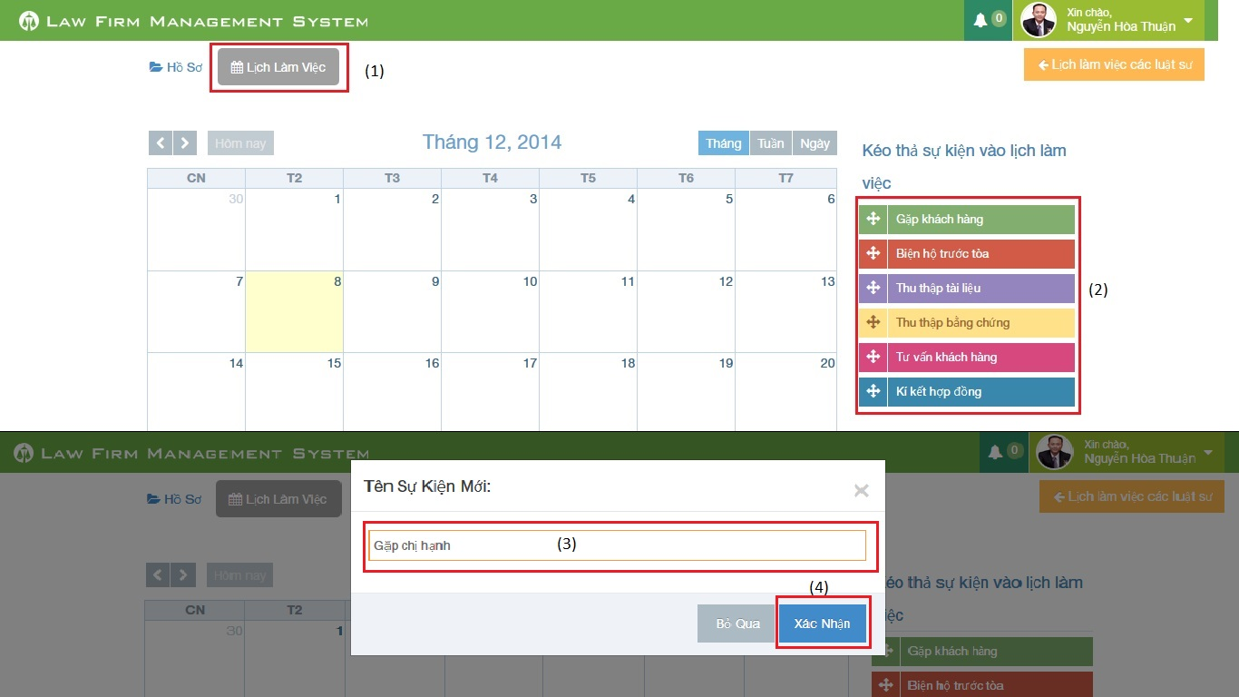

Figure 1: How to create a Calendar Event

|  |  |
| --- | --- |
| Step | Description |
| 1 | At Index page, click at “Lịch làm việc” tab |
| 2 | Drag any event and drop it into calendar.  (User can also click or click and drag anywhere in calendar to create a new event) |
| 3 | Input New calendar event name. |
| 4 | Press “Xác nhận” button to create new calendar event. |

### How to view calendar event of other lawyer

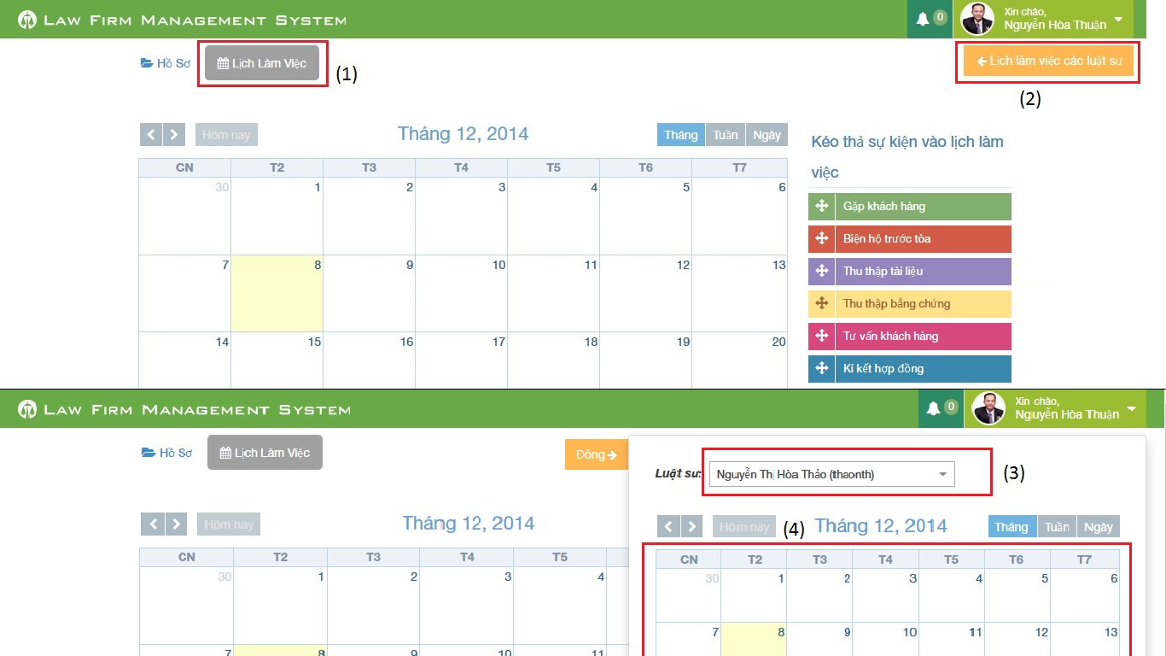

Figure 2: How to view calendar event of other lawyer

|  |  |
| --- | --- |
| Step | Description |
| 1 | At Index page, click at “Lịch làm việc” tab |
| 2 | At “Lịch làm việc” tab click at “Lịch làm việc các luật sư” |
| 3 | Choose a name of lawyer user want to view at combo-box |
| 4 | Calendar event will show below combo-box |

### How to create an Operation Event

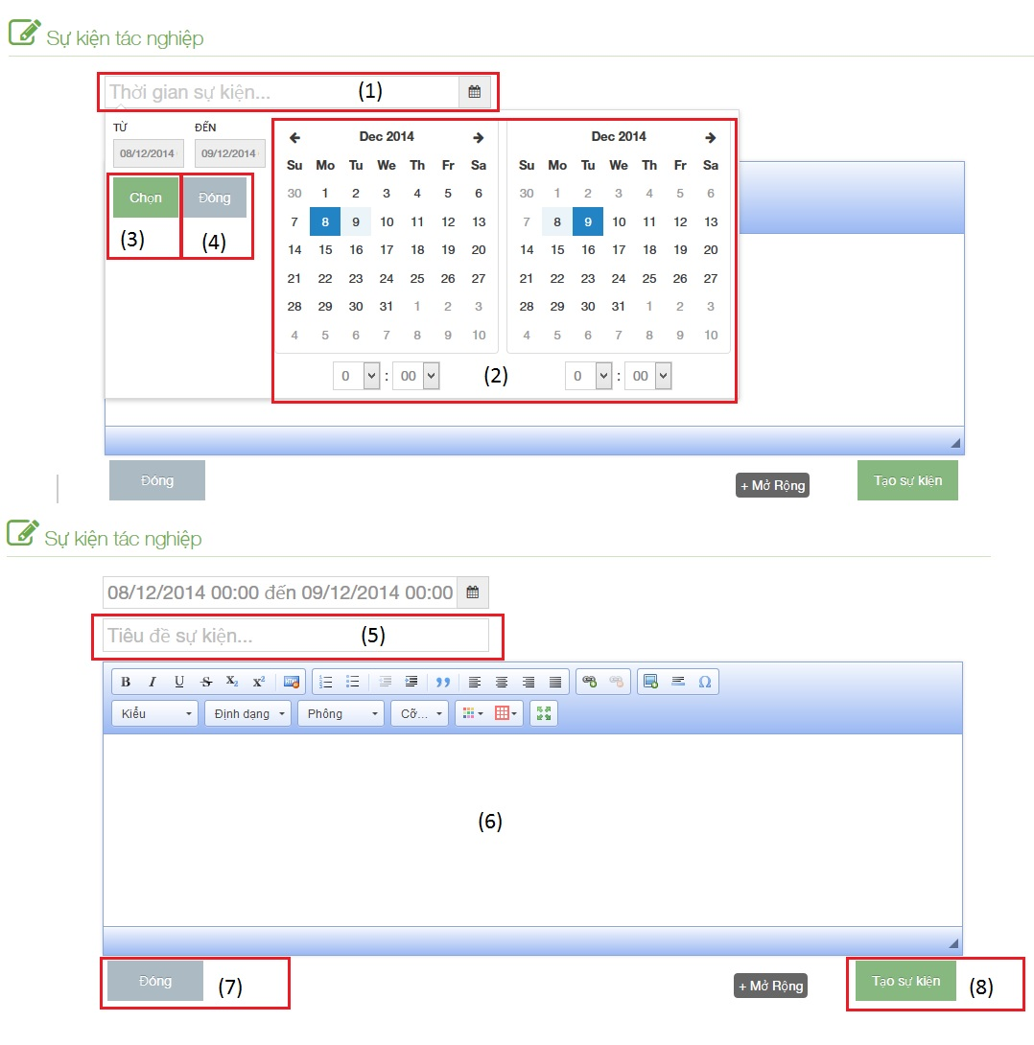

Figure 3: How to create an Operation Event

|  |  |
| --- | --- |
| Step | Description |
| 1 | Click to text box to add time start and finish of event |
| 2 | Choose date and time of event |
| 3 | Click [Chọn] button to input data on “Thời gian sự kiện” |
| 4 | Click [Đóng] button to cancel input |
| 5 | Input title of event |
| 6 | Input content of event include: text, image…. |
| 7 | Click [Đóng] button to close Popup and back to [List event] screen |
| 8 | Click [Tạo sự kiện] to insert new operation event |

### How to upload photos to Documents Related

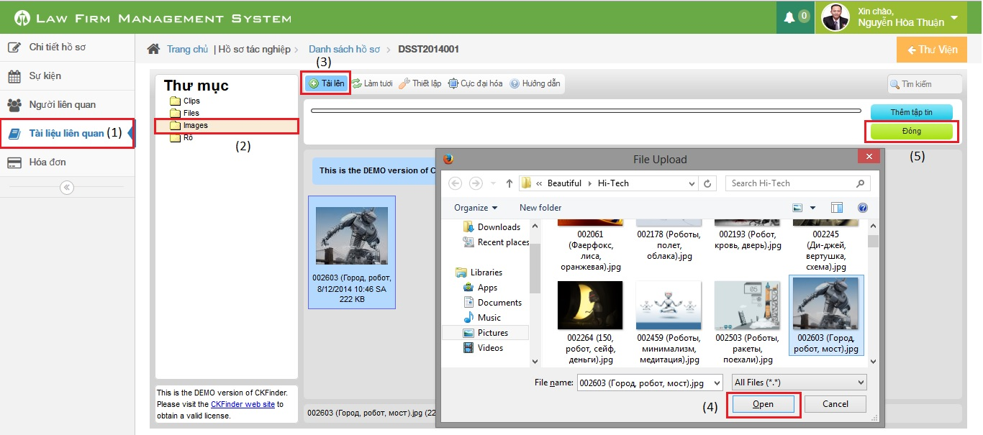

Figure 4: How to upload photos to Documents Related

|  |  |
| --- | --- |
| Step | Description |
| 1 | Go to case detail page and then click on “Tài liệu liên quan” link |
| 2 | Click on “Images” button (can upload only image file format) |
| 3 | Click on “Tải lên” button to show a popup |
| 4 | Choose one or many photos and then click “Open” button |
| 5 | Click on “Đóng” button to complete upload |

### How to create a case

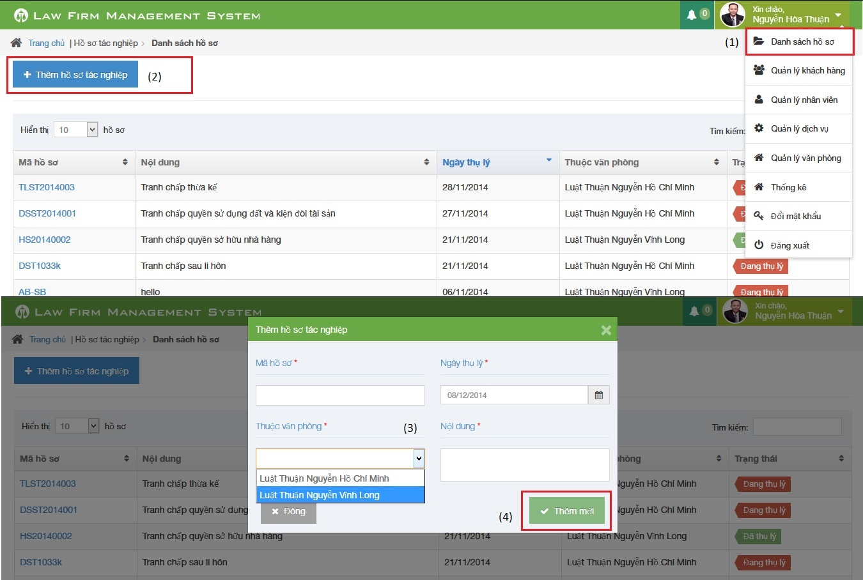

Figure 5: How to create a Case

|  |  |
| --- | --- |
| Step | Description |
| 1 | Click on list menu and then choose “Danh sách hồ sơ” to go to view list case page |
| 2 | Click on “Thêm hồ sơ tác nghiệp” to show a popup |
| 3 | Fill information of case:  - Mã hồ sơ, Ngày thụ lý, Thuộc văn phòng, Nội dung is required |
| 4 | Click [Thêm mới] button to insert new case |

### How to create a customer

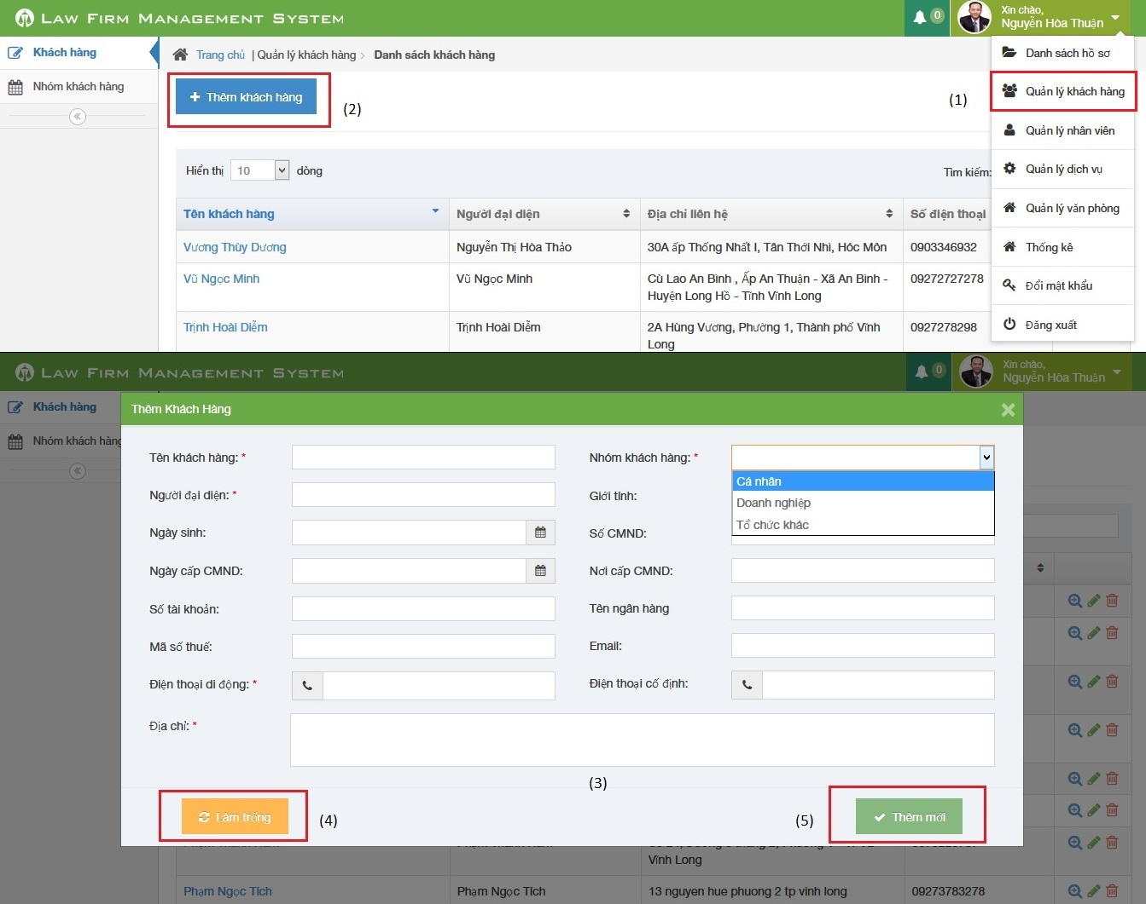

Figure 6: How to create a Customer

|  |  |
| --- | --- |
| Step | Description |
| 1 | Click on list menu and then choose “Quản lý khách hàng” to go to view list customer page |
| 2 | Click on “Thêm khách hàng” to show a popup |
| 3 | Fill information of case:  - Tên khách hàng, Người đại diện, Nhóm khách hàng, Điện thoại di động, Địa chỉ is required  - Điện thoại di động, Điện thoại cố định, số CMND, Mã số thuế, Số tài khoản must be number  - Email to compliance with format |
| 4 | Click [Làm trống] button to clear all fill to blank. |
| 5 | Click [Thêm mới] button to insert new customer |

### How to create a Staff

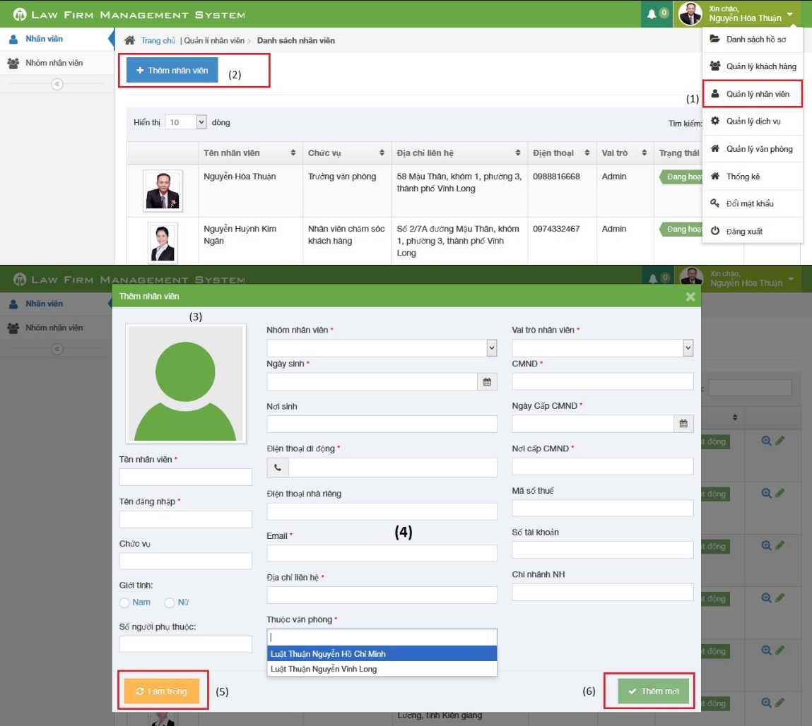

Figure 7: How to create a Staff

|  |  |
| --- | --- |
| Step | Description |
| 1 | Click on list menu and then choose “Quản lý nhân viên” to go to view list staff page |
| 2 | Click on “Thêm nhân viên” to show a popup |
| 3 | Click to input avatar of staff |
| 4 | Fill information of staff:  - Tên nhân viên, Tên đăng nhập, Nhóm nhân viên, Ngày sinh, Điện thoại di động, Email, Địa chỉ liên hệ, Thuộc văn phòng, Vai trò nhân viên, CMND, Ngày cấp CMND, Nơi cấp CMND is required  - Điện thoại di động, Điện thoại nhà riêng, CMND, Mã số thuế, Số tài khoản must be number  - Email to compliance with format |
| 5 | Click [Làm trống] button to clear all fill to blank. |
| 6 | Click [Thêm mới] button to insert new staff |

### How to create a service

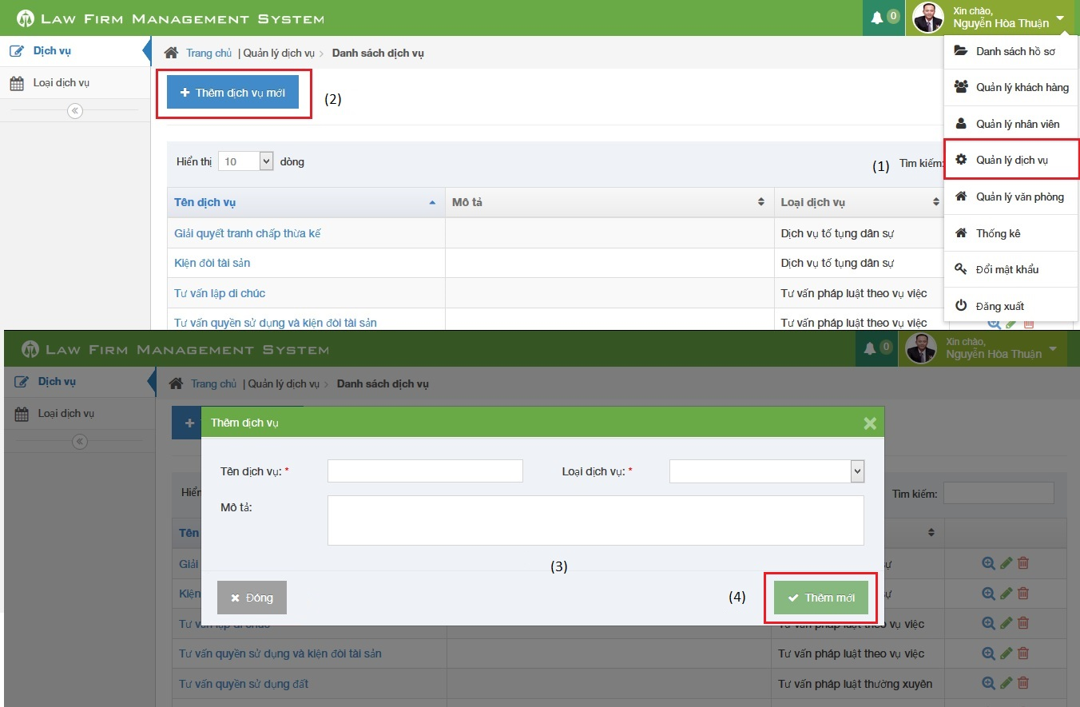

Figure 8: How to create a service

|  |  |
| --- | --- |
| Step | Description |
| 1 | Click on list menu and then choose “Quản lý dịch vụ” to go to view list service page |
| 2 | Click on “Thêm dịch vụ mới” to show a popup |
| 3 | Fill information of case:  - Tên dịch vụ, Loại dịch vụ is required |
| 4 | Click [Thêm mới] button to insert new service |

### How to create an office

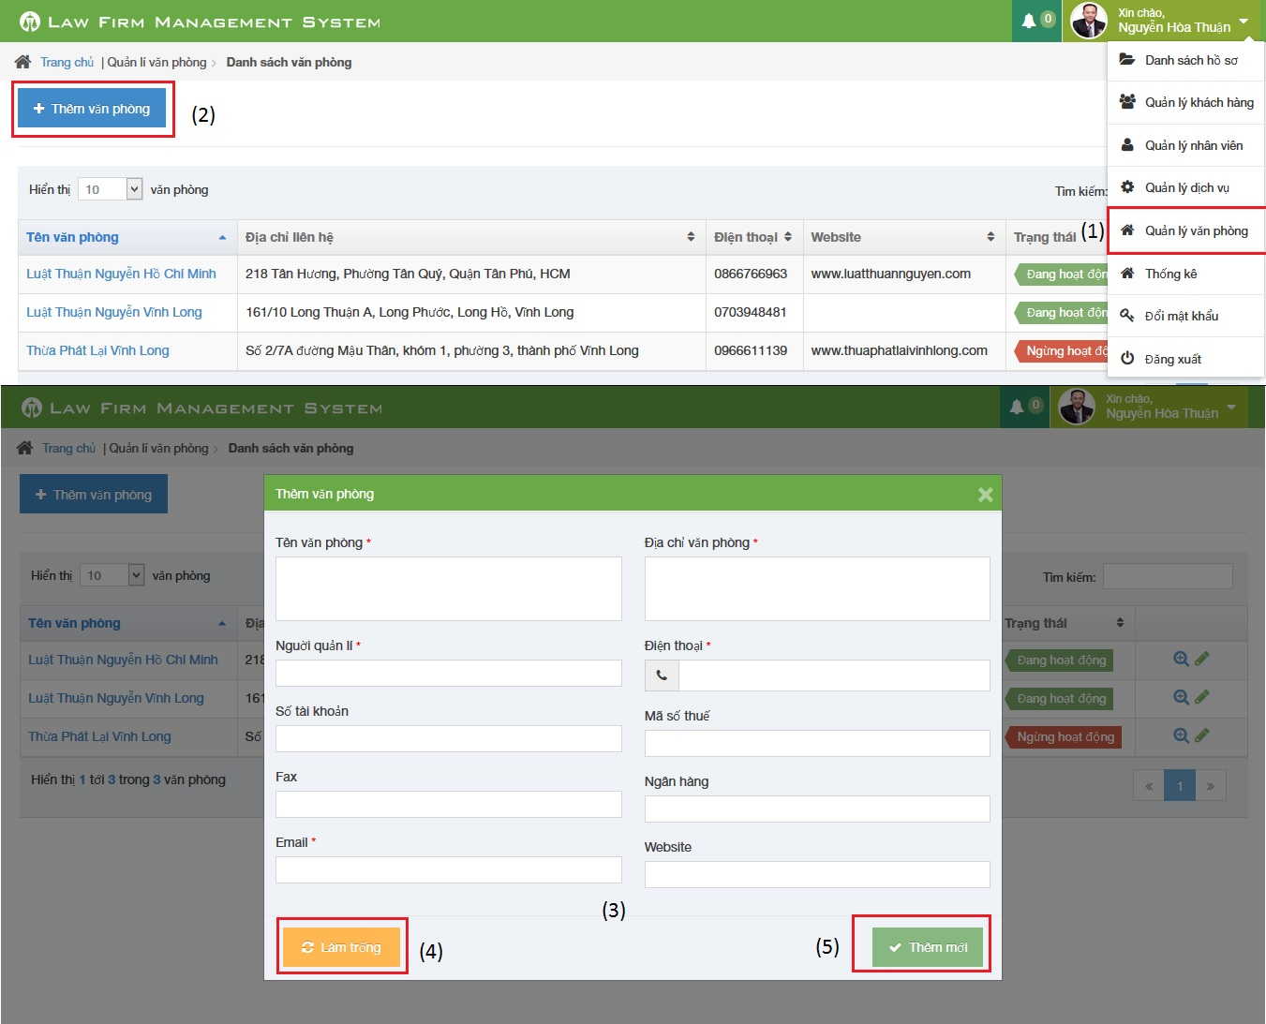

Figure 7: How to create a Staff

|  |  |
| --- | --- |
| Step | Description |
| 1 | Click on list menu and then choose “Quản lý văn phòng” to go to view list office page |
| 2 | Click on “Thêm văn phòng” to show a popup |
| 3 | Fill information of case:  - Tên văn phòng, Địa chỉ văn phòng, Người quản lí, Điện thoại, Email is required  - Điện thoại, Mã số thuế, Số tài khoản must be number  - Email to compliance with format |
| 4 | Click [Làm trống] button to clear all fill to blank. |
| 5 | Click [Thêm mới] button to insert new service |

### How to view statistic

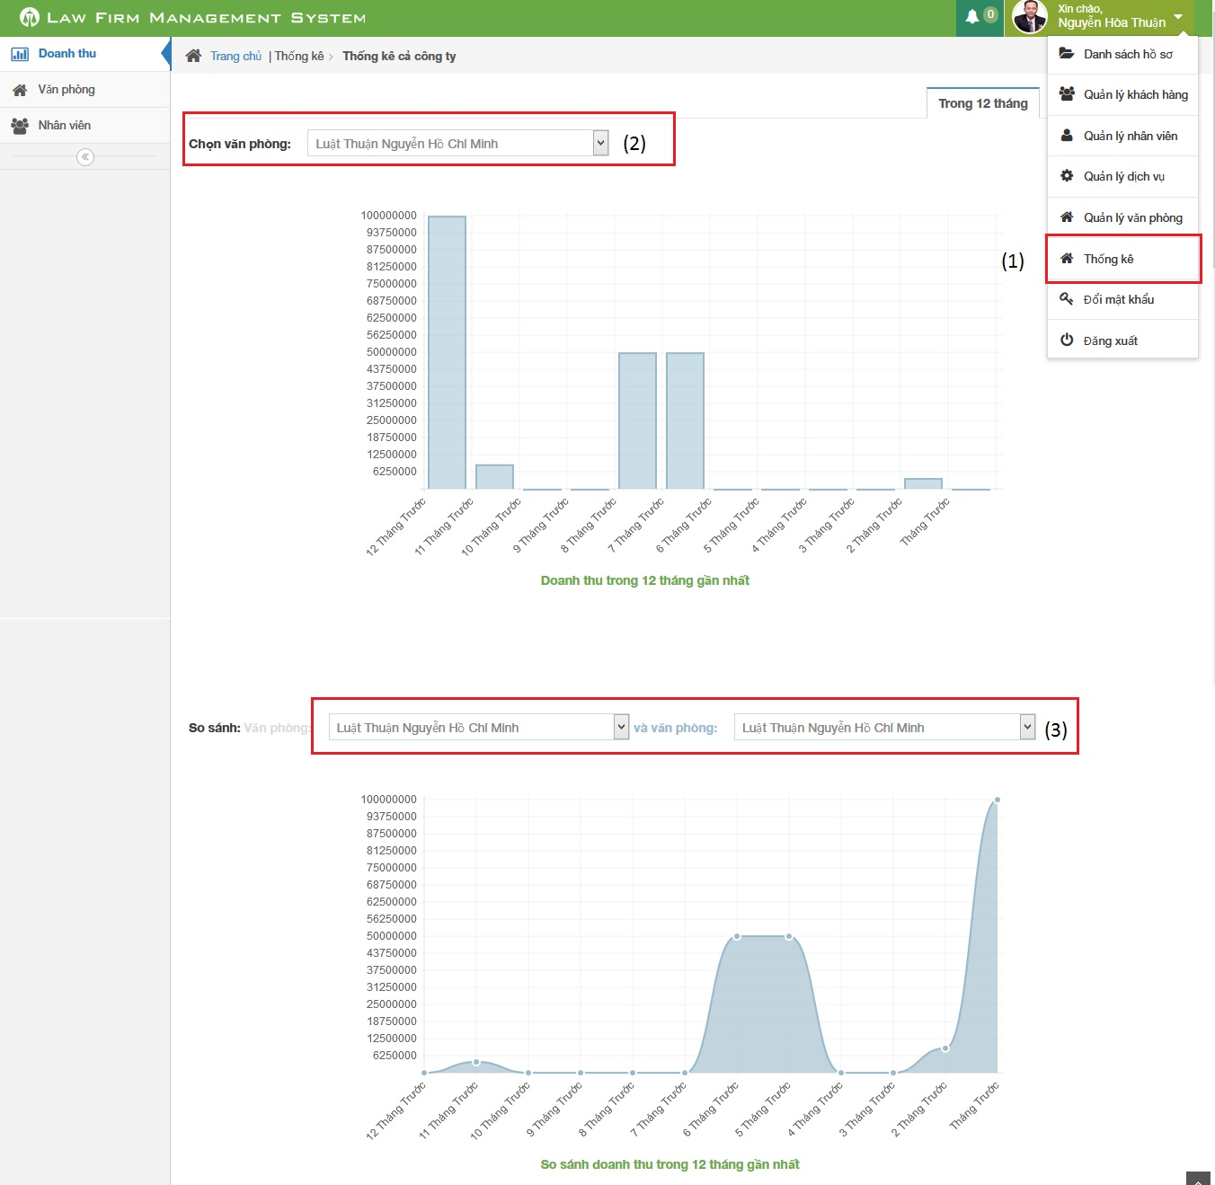

Figure 8: How to view statistic

|  |  |
| --- | --- |
| Step | Description |
| 1 | Click on list menu and then choose “Thống kê” to go to view list statistic page |
| 2 | Choose office user want to show statistic |
| 3 | Choose two office user want to compare in statistic |

**End.**